**Presentation Notes:**

1. What are the four functions of a computer program listed on the lesson slide?
   1. Makes decisions on how input devices will affect output devices.
   2. Controls hardware of a computer system.
   3. Controls what happens if you click the mouse button.
   4. Allows you to change functions of one hardware.
2. Provide an example of a computer input that is not listed on the lesson slide.

An example of a computer input can be the track ball on a mouse.

1. Provide an example of a computer output that is not listed on the lesson slide.

An example of a computer output can be the movement of the mouse.

1. Provide another example of how a computer input affects a computer output that is not listed on the lesson slide.

An example of a computer input affecting a computer output can be when you speak in a microphone (input), the sound will come out on a speaker (output).

1. Provide an example of how changing the program changes how computer inputs affect computer outputs that is not listed on the lesson slide.

An example of changing computer programs and it affecting the output with the same input can be in video games, in video games the controls for movement are switched to w,a,s,d (input) to move your character(output) instead of typing words like their traditional meanings.

1. What are some examples of devices that are not traditional computers but that make use of computer programs?
   1. Refrigerators
   2. Alarm clocks
   3. Robots
   4. Cars
   5. Toasters
2. Provide another example of a device that makes use of a computer program that is not listed on the lesson slide.

An example of a device that uses computer program is a telephone as Party’s such as liberal use computer program to send messages and voicemails to make people vote for them.

1. What is another term for a computer program?

Another term for computer program can be Computer software.

1. What are some ways that computer software is different from computer hardware?

Software uses logic and it is easily changed whereas hardware uses physical circuits and it is very difficult to change.

1. How are computer programs written?

Computer programs are written in text, can use text editor. You type it in through your keyboard which then you store in a file which then you can run a computer code on your computer.

1. Why are computer programs composed of many lines of computer code?

Each line does a very simple command, in order to have a computer code that is complete it has to be composed with many lines.

1. List some examples of different computer languages.
   1. Phython
   2. C/C+
   3. Java
   4. SQL
2. List some of the benefits of the Python computer language.
   1. Good for prototyping small programs
   2. Its professional with a large user base.
   3. Good beginner language
   4. Language of choice for first year university courses.
3. Once you finish this course, how could you answer someone who asks you "Do you know how to program in Java?"

I would answer with yes; this is because programming concepts are the in all languages so once you learn one language you can use any language.

1. Could you use Microsoft Word to write a computer program? Explain.

Yes, programs can be written in nearly any text editor however it lacks support which makes programming harder.

1. What does IDE stand for?

IDE stands for Integrated Development Environment

1. What are some features of an Integrated Development Environment?
   1. Colour coding of keywords.
   2. Indentation and completion control.
   3. Error Checking.
   4. Runtime support and debugging.
   5. Find problems right when writing code.
2. What are some factors to consider when choosing an Integrated Development Environment?
   1. Support for chosen language?
   2. Web based or download?
   3. Does it cost money?
3. What is the name of the IDE that we will be using to create our Python programs?

The IDE that we are going to use to create our Python programs is Repl.it.

1. What version of Python will we be using?

The version of Python that we will be using is Python 3.7.3.

1. Draw a sketch of the Repl interface showing the three work areas (panels)
   1. Label each panel
   2. Summarize the function of each panel

Use white area for longer programs

Use black area for simple commands or one line.

Use buttons at top to run your program.

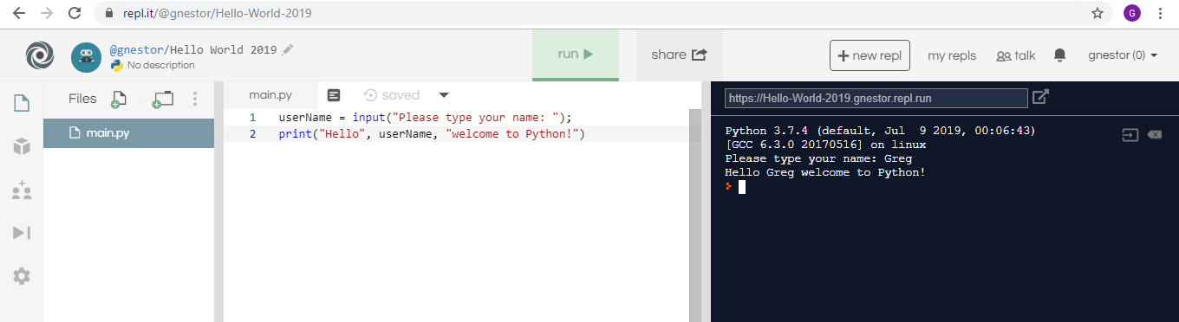

**Student Questions:**

1. Create an account for yourself at www.repl.it
   1. Review the "Terms of Service" to verify that you can legally use this service.
   2. Follow the previous discussed guidelines regarding use of personal information
2. List the part of the "Terms of Service” that verifies that you can legally use this service.

The part that verifies we can legally use this service is the section Accounts; Accounts Termination Policy.

1. Explain some of the rights that you give away to Repl.it regarding content you create using their service?

By using the service Repl.it, you give up the right to personal information. The service collects personal information from users and visitors in which they store your name and your email address. Some other things that are collected automatically is your log information, which is your IP Address, your browser type, internet service provider, platform type device type, etc.

1. Create a new Python repl and call it "Hello World".
2. Copy and paste the following program into the program panel (white area)

userName = input("Please type your name: ");

print("Hello", userName, "welcome to Python!")

1. Run the program to see what it does. (If necessary, fix the quotation marks so it runs properly.)
   1. Explain how the program works.

The program works by adding codes to the white screen such as print (“Hello”), and by running the program it will display what you have coded on the black screen.

* 1. Explain how you fixed the program (if necessary)

1. Try using the console pane (black area) to perform some simple calculations and run some one-line programs.
   1. Summarize some of your calculations.

On the console pad, I did simple calculations such as 5 * 6 which gave me 30 on the next line.

8.Try using the file management pane to add some files and folders to your repl.

1. Summarize some of your additions.

During my additions I added a folder in which I placed my original file in and created another file which I added other codes into.